

The header and course component is child component of app component.

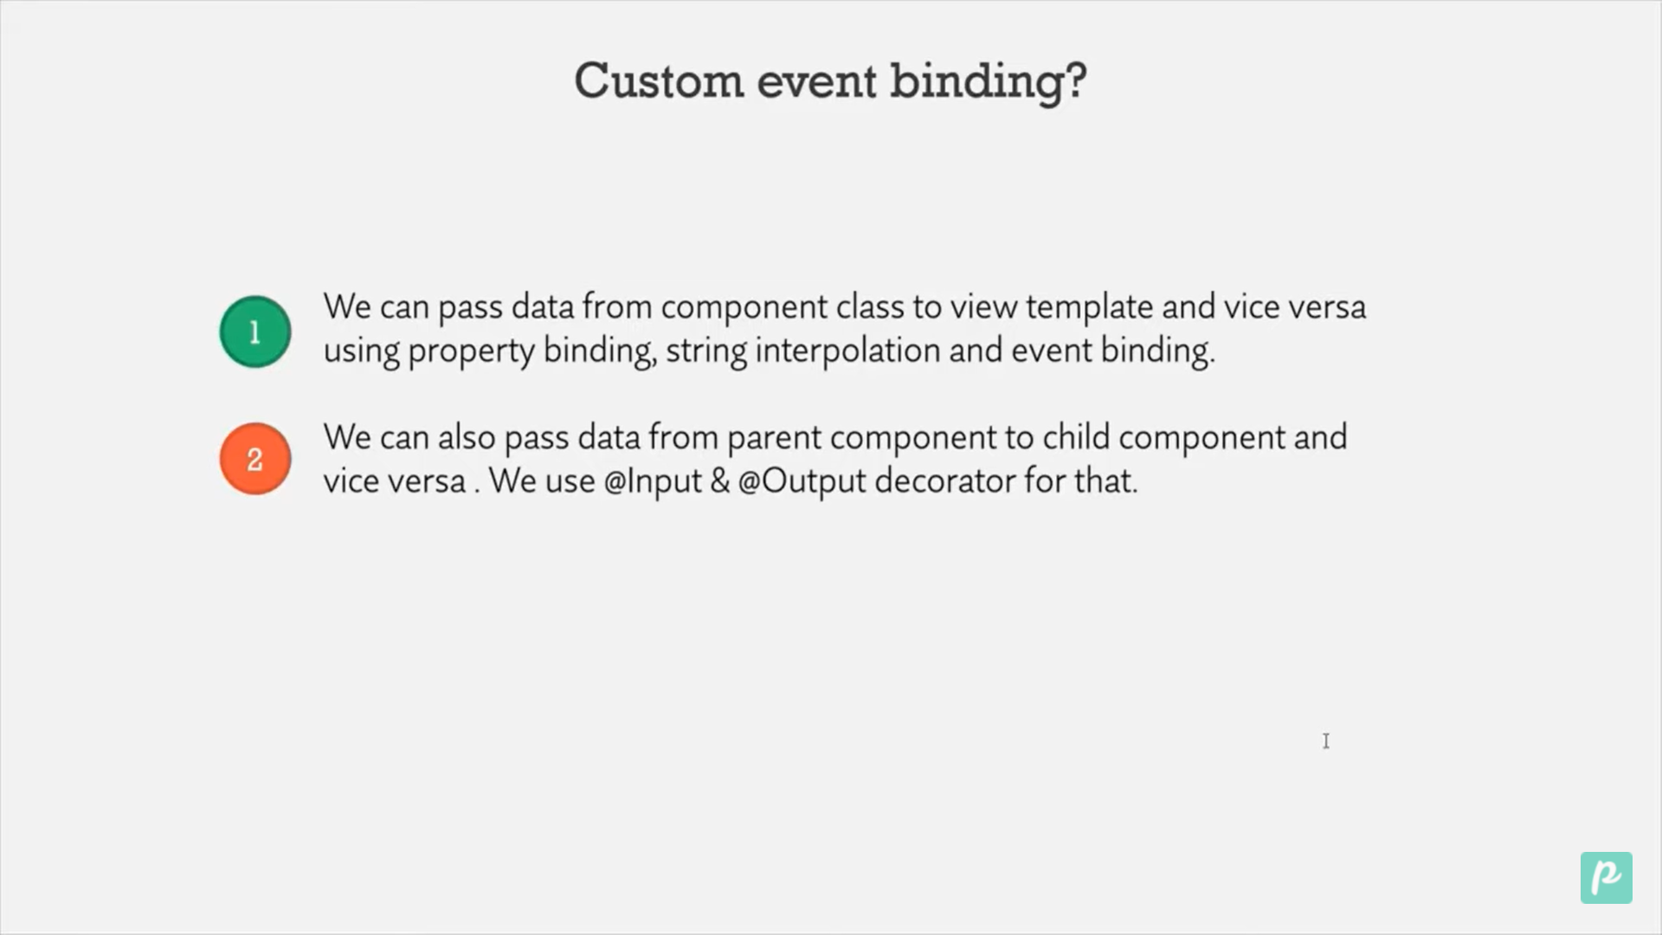

@Input form Parent to child

@Output form child to Parent component

Step1 :We will create Find component : to search the things .

Step 2: We will create filter component to filter the things. It contain 3 raido button abd based on that it will display the items.

Product is parent component which contains the array of product .

Filter is Child component based on filter we will display the products.

View Template

<span>Filter</span> &nbsp;&nbsp;

<input type="radio" name="filter" value="available" />

All coursess({{ all }})&nbsp; &nbsp;

<input type="radio" name="filter" value="available" /> Available({{

  available

}})&nbsp; &nbsp;

<input type="radio" name="filter" value="notavailable" /> NotAvailable({{

  notavailable

}})<br />

Class

@Component({

  selector: 'app-filter',

  templateUrl: './filter.component.html',

  styleUrls: ['./filter.component.css'],

})

export class FilterComponent {

  all: number = 0;

  available: number = 0;

  notavailable: number = 0;

}

@Input Binding will be used to pass the element form parent to child.



Step1: Now in Child class we will have to import Input

import { Component, Input } from '@angular/core';

Step 2: Create variable for which we want value form parent component.

@Input() all: number = 0;

  @Input() available: number = 0;

  @Input() notavailable: number = 0;

Step 3: In Parent Component call child Component and the variable will get value form parent methods

</div>

<div><app-find></app-find></div>

<app-filter

  [all]="getAll()"

  [available]="getAvailable()"

  [notavailable]="getNotAvailable()"

></app-filter>

Step 4: Create Methods in parent component.

 getAll() {

    return this.pro.length;

  }

  getAvailable() {

    return this.pro.filter((x) => x.details == 'availabe').length;

  }

  getNotAvailable() {

    return this.pro.filter((y) => y.details == 'notavailabe').length;

  }

We have array of product in parent component

export class ProductsComponent {

  pro = [

    { id: 1, name: 'Sam', phNumber: 123456789, details: 'availabe' },

    { id: 2, name: 'Pam', phNumber: 213456789, details: 'availabe' },

    { id: 3, name: 'Tam', phNumber: 123456789, details: 'notavailabe' },

    { id: 4, name: 'Ram', phNumber: 123456789, details: 'availabe' },

    { id: 5, name: 'Gam', phNumber: 123456789, details: 'notavailabe' },

    { id: 6, name: 'Saam', phNumber: 123456789, details: 'availabe' },

    { id: 7, name: 'Tuam', phNumber: 123456789, details: 'notavailabe' },

    { id: 8, name: 'Xam', phNumber: 123456789, details: 'availabe' },

  ];